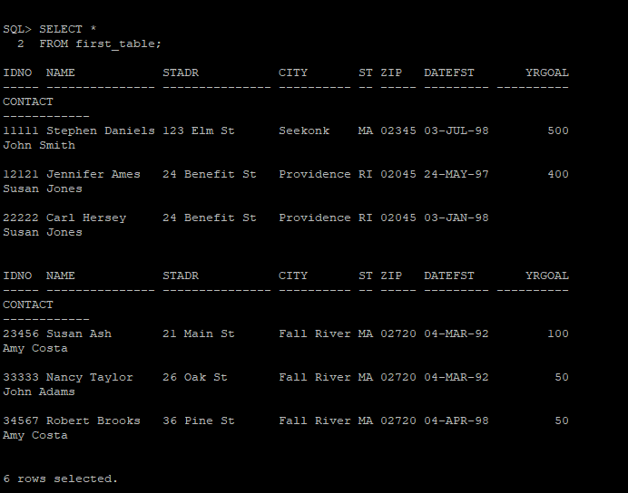

1.)
SQL> select idno, name, city, yrgoal from first_table;

IDNO NAME CITY YRGOAL
----- --------------- ---------- ----------
11111 Stephen Daniels Seekonk 500
12121 Jennifer Ames Providence 400
22222 Carl Hersey Providence
23456 Susan Ash Fall River 100
33333 Nancy Taylor Fall River 50
34567 Robert Brooks Fall River 50

6 rows selected.

2.)
SQL> select name, state from first_table;

NAME ST
--------------- --
Stephen Daniels MA
Jennifer Ames RI
Carl Hersey RI
Susan Ash MA
Nancy Taylor MA
Robert Brooks MA

6 rows selected.

3)
SQL> select *
2 from first_table
3 order by city desc;

IDNO NAME STADR CITY ST ZIP DATEFST YRGOAL
----- --------------- --------------- ---------- -- ----- --------- ----------
CONTACT
------------
11111 Stephen Daniels 123 Elm St Seekonk MA 02345 03-JUL-98 500
John Smith

12121 Jennifer Ames 24 Benefit St Providence RI 02045 24-MAY-97 400
Susan Jones

22222 Carl Hersey 24 Benefit St Providence RI 02045 03-JAN-98
Susan Jones

IDNO NAME STADR CITY ST ZIP DATEFST YRGOAL
----- --------------- --------------- ---------- -- ----- --------- ----------
CONTACT
------------
23456 Susan Ash 21 Main St Fall River MA 02720 04-MAR-92 100
Amy Costa

33333 Nancy Taylor 26 Oak St Fall River MA 02720 04-MAR-92 50
John Adams

34567 Robert Brooks 36 Pine St Fall River MA 02720 04-APR-98 50
Amy Costa

6 rows selected.

4)
SQL> select *
2 from first_table
3 order by city, yrgoal DESC;

IDNO NAME STADR CITY ST ZIP DATEFST YRGOAL
----- --------------- --------------- ---------- -- ----- --------- ----------
CONTACT
------------
23456 Susan Ash 21 Main St Fall River MA 02720 04-MAR-92 100
Amy Costa

33333 Nancy Taylor 26 Oak St Fall River MA 02720 04-MAR-92 50
John Adams

34567 Robert Brooks 36 Pine St Fall River MA 02720 04-APR-98 50
Amy Costa

IDNO NAME STADR CITY ST ZIP DATEFST YRGOAL
----- --------------- --------------- ---------- -- ----- --------- ----------
CONTACT
------------
22222 Carl Hersey 24 Benefit St Providence RI 02045 03-JAN-98
Susan Jones

12121 Jennifer Ames 24 Benefit St Providence RI 02045 24-MAY-97 400
Susan Jones

11111 Stephen Daniels 123 Elm St Seekonk MA 02345 03-JUL-98 500
John Smith

5)

6)
SQL> select name
2 from first_table
3 where name = 'Jo';

no rows selected

7)
SQL> SELECT NAME
2 FROM donor
3 WHERE NAME BETWEEN 'J' AND 'R';

NAME
---------------
Jennifer Ames
Nancy Taylor

8)
SQL> select *
2 from first_table
3 where city IN ('Providence','Seekonk','Westport');

IDNO NAME STADR CITY ST ZIP DATEFST YRGOAL
----- --------------- --------------- ---------- -- ----- --------- ----------
CONTACT
------------
11111 Stephen Daniels 123 Elm St Seekonk MA 02345 03-JUL-98 500
John Smith

12121 Jennifer Ames 24 Benefit St Providence RI 02045 24-MAY-97 400
Susan Jones

22222 Carl Hersey 24 Benefit St Providence RI 02045 03-JAN-98
Susan Jones

9)
SQL> select *
2 from first_table
3 where datefst IN ('1-JAN-97','31-DEC-98');

no rows selected

10)

